- 4^{√x+1}= 64. 2^{√x+1} 3^{2x-1} + 3^{2x--2} - 3^{2x-4} = 315 √2 . ³√4^{3-5x} = 4. √2^{5-7x}
- 2^{3t} + 2^{3t-1} + 2^{3t-2} + 2^{3t-3} = 120 4^{x} . 5^{x+1} = 5. 20 ^{2-x} 4. √2^{5-7x} = √2 . ³√4^{3-5x}
- 9^{v+2} + 5. 9^{v+1} = 14 3^{v-1} + 3^{v-2} + 3 ^{v-3} = 13 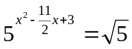
- 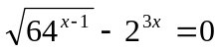 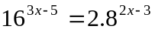 2^{x+1} - 2^{x} + 2^{x-1} = 12
- 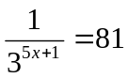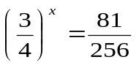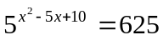
- 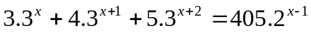
- 3 ^{x+2} + 9 ^{x+1} – 810 = 0 6 ^{1+x} + 6 ^{1-x} = 13 25 ^{2x} – 3. 25 ^{x} = 10

